This part of the process is completed outside of the YEAH system.
- Using a standard size sheet of paper, make your signature in the normal size that you would when signing any document using BLUE ink.
- Scan that page with your signature
  - Typically, the file will be saved as in a .pdf format
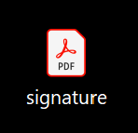
- Open the .pdf file
- If using a Windows computer, open the application called Snipping Tool
  - 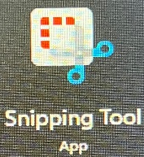
- Use the Snipping Tool to select your signature
- Save your signature as a .jpg file

Now, you are ready to go into the YEAH system
- Log into YEAH
- Go to “Utilities” >> “District Information”
- Double-click on your name (or the one you are adding the signature for) and it will open the District Officers
- At the bottom left you will see a box that says “Signature of District Chair” – click on the “ + “ sign
- The following screen should appear:
  - 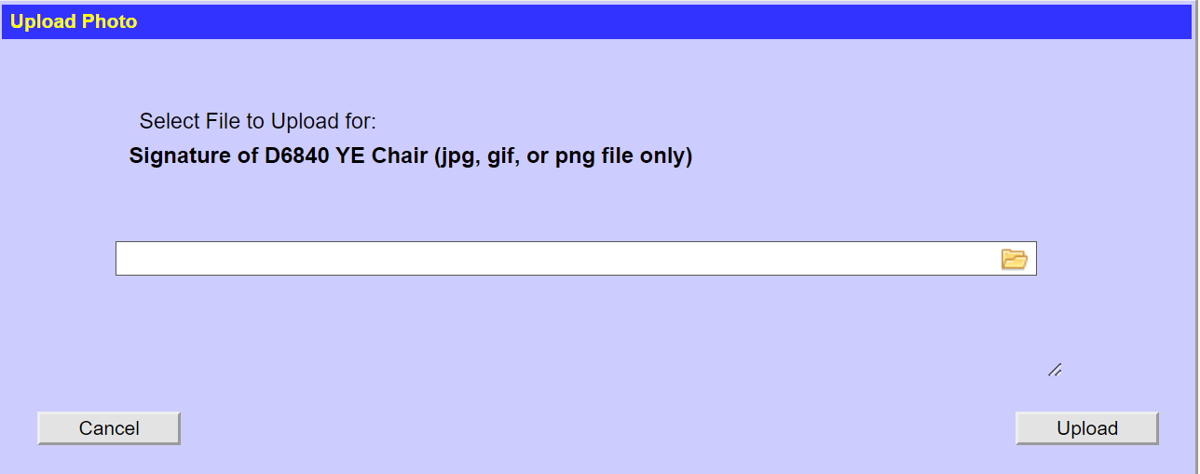
- Click on the icon that looks like a folder
- File explorer will open and you will need to find the .jpg file that you created earlier; select it.
- The file name should appear:
  - 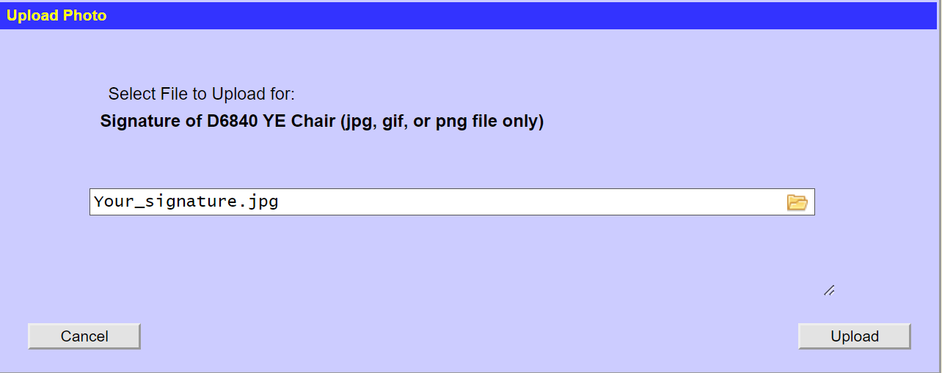
- Click Upload
- You should now be able to see your Signature in the box on the District Officer tab

